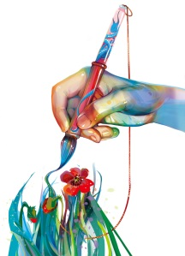

**Sunday, September 24, 2017**

9am-3pm

Killens Pond State Park – Felton, DE

Featuring handmade arts and crafts

**Art in the park**

**1st Annual Killens Pond State Park Arts in the Park**

**$50 per vendor**

All types of arts/crafts will be considered, however, this is a juried event.

**Applications must include photos and copies of receipts or materials list**. Incomplete applications will not be considered. You do not need to send photos of every item you will be selling; however, booths will be checked the morning of the event. You will be asked to remove any item(s) that are wholesale or mass produced. We have access to the wholesale shops in Lancaster and the internet. Please submit only your items.

Spaces will be assigned on a first come, first served basis. There will be a limit of FIVE spaces per type of artist (jewelry, quilting, paintings, woodwork, etc). This is to prevent 25 of one type of vendor. Your space is not guaranteed until payment has been processed. If your application is incomplete, it will be returned. Food trucks will be on site, and a radio station will be broadcasting live from our location.

**Application Deadline is August 15, 2017 – NO EXCEPTIONS**

**Please be aware there will not be a rain date, and refunds will not be given in the event of rain.**

By mail – make checks payable to KPSP and mail to: Killens Pond State Park,

Arts in the Park, 5025 Killens Pond Road, Felton, DE 19943

In person – check or Visa/MC at the park office (address above) M-F 8am-4pm

Questions? 302-284-4526 or email [leslie.bird@state.de.us](mailto:leslie.bird@state.de.us)

Please include with payment (by August 15, 2017):

Name: _____________________________________________________

Address: ___________________________________________________

Phone: _____________________________________________________

Email: _____________________________________________________